2D Beam Patterns
Kevin Sterne 8/7/2013

3D pattern at 11 MHz (steered 15° off boresight):
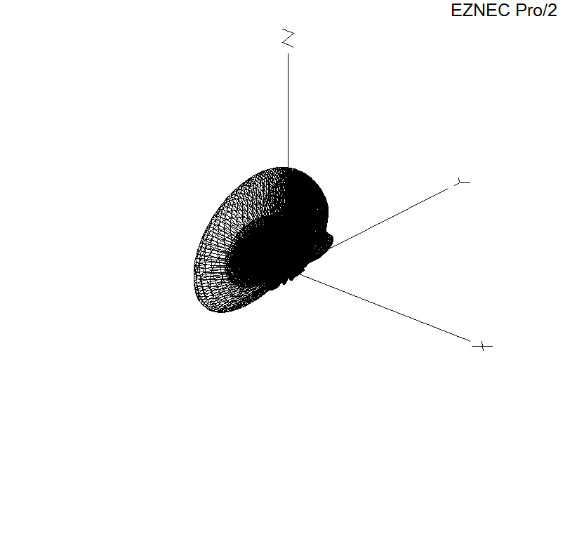
15° Steered, Azimuth slice, 10° elevation, 11MHz:
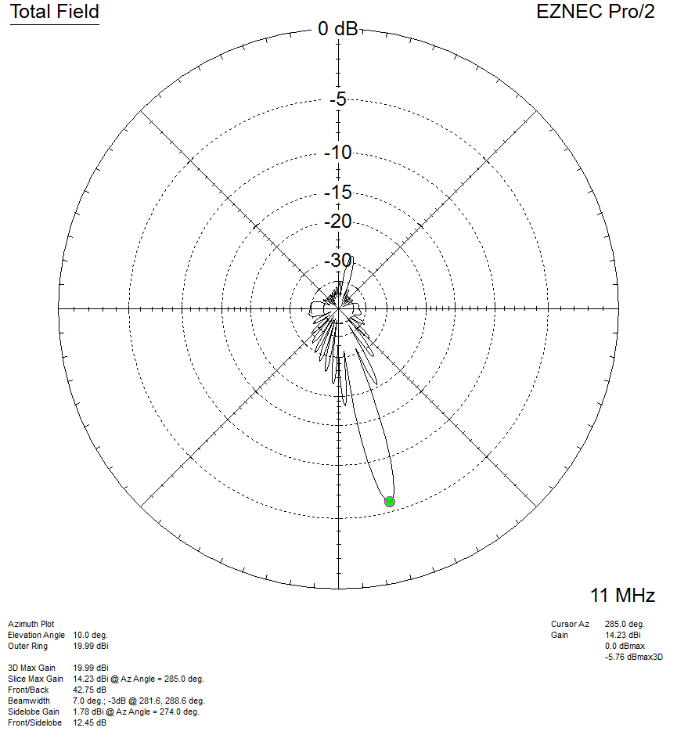

15° Steered, Azimuth slice, 15° elevation, 11MHz:
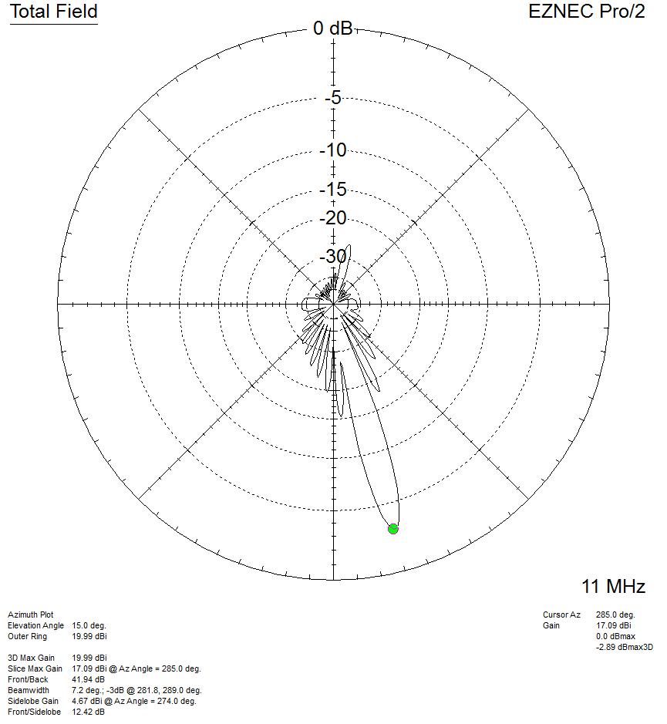

15° Steered, Azimuth slice, 20° elevation, 11MHz:
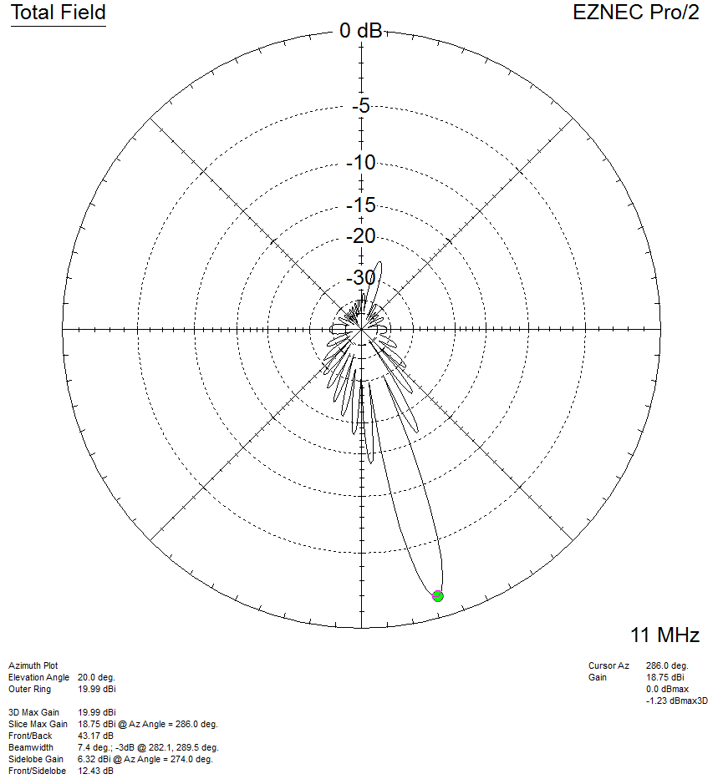

15° Steered, Azimuth slice, 25° elevation, 11MHz:
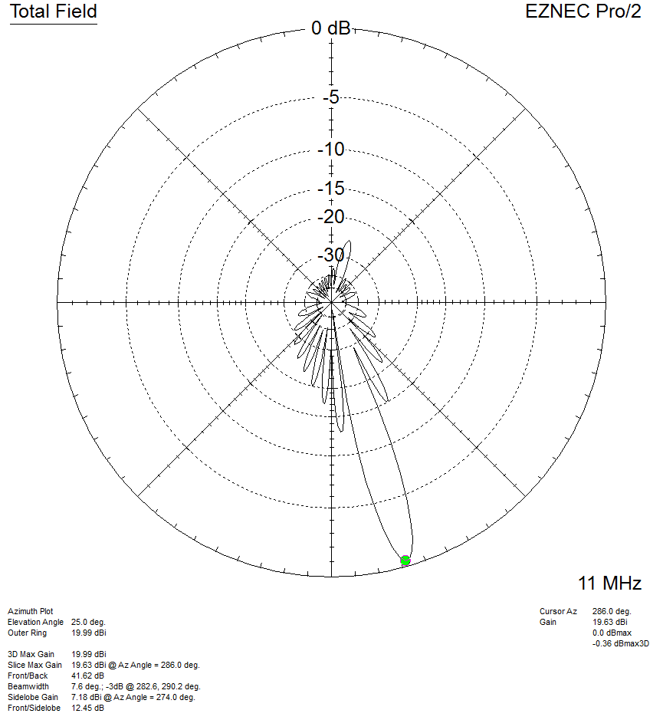

15° Steered, Azimuth slice, 30° elevation, 11MHz:
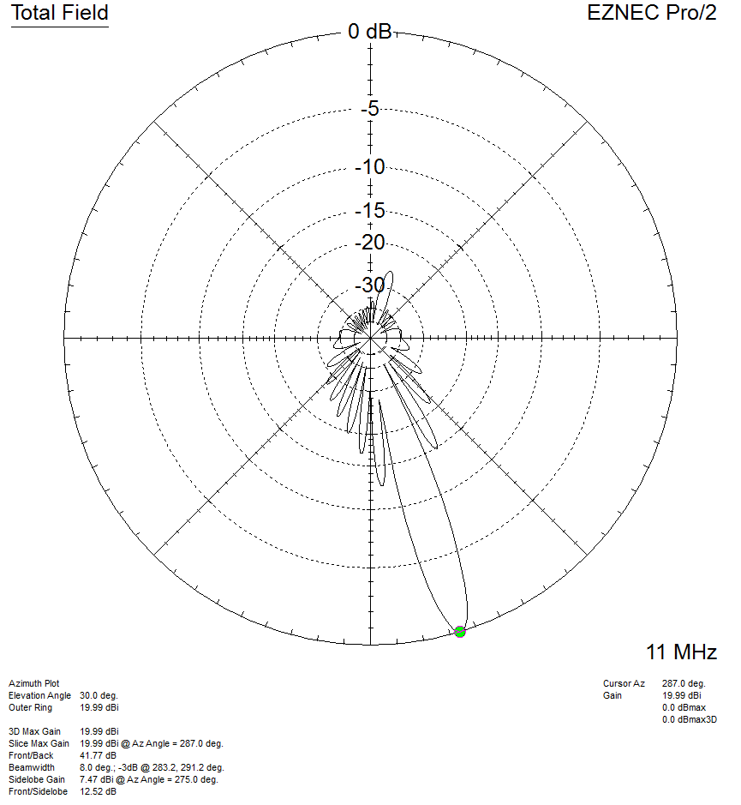

15° Steered, Azimuth slice, 35° elevation, 11MHz:
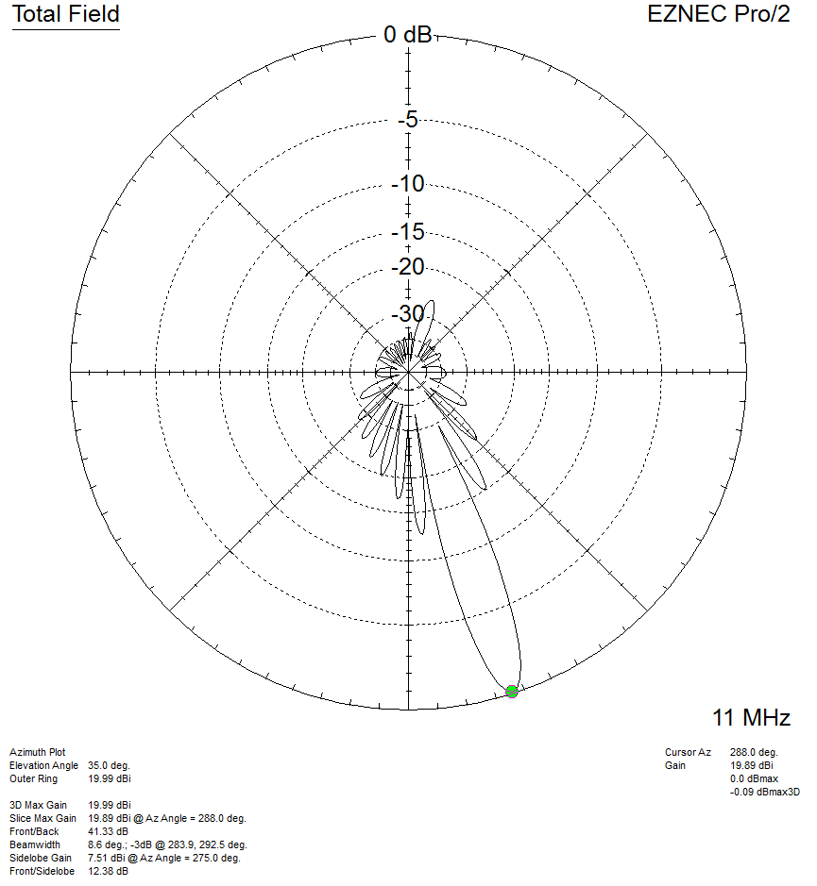

15° Steered, Azimuth slice, 40° elevation, 11MHz:
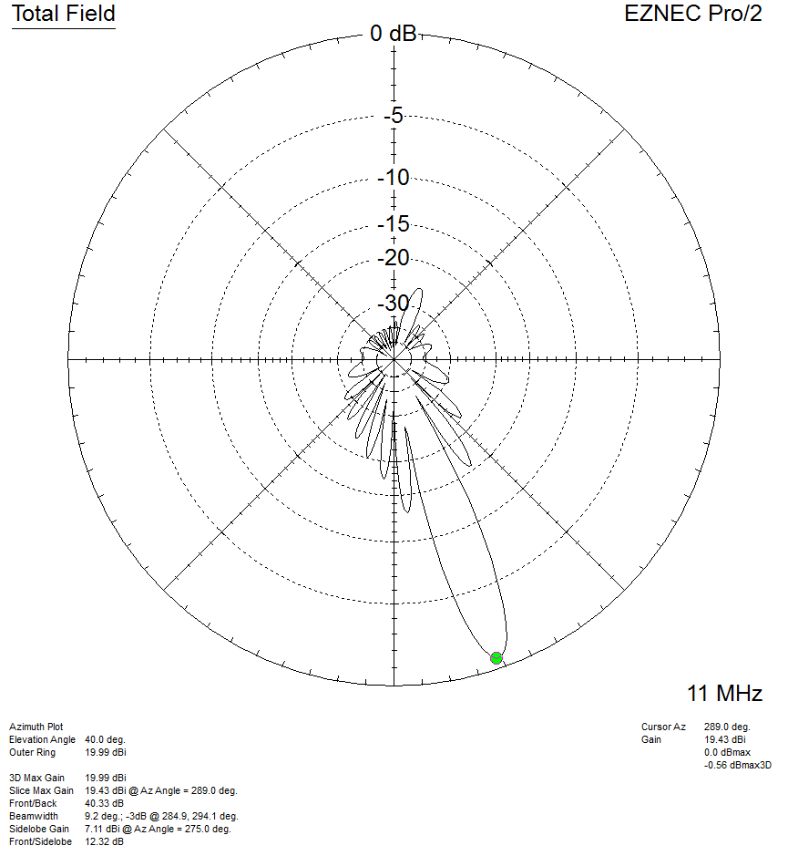

15° Steered, Azimuth slice, 45° elevation, 11MHz:
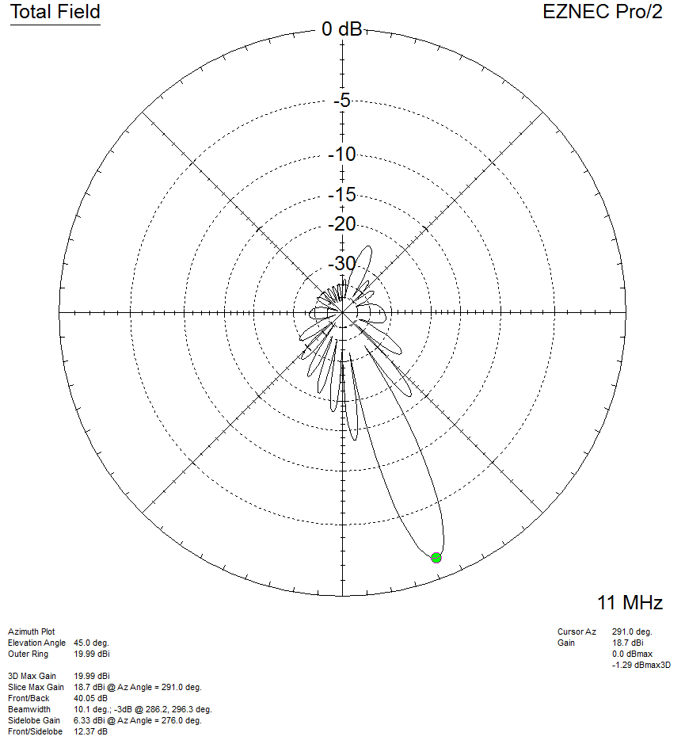

3D pattern at 14 MHz (steered 15° off boresight):
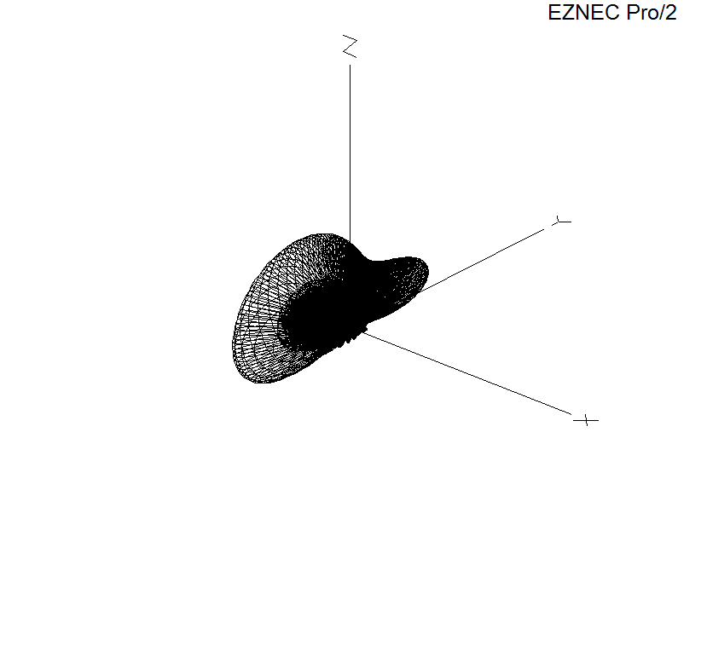

15° Steered, Azimuth slice, 10° elevation, 14MHz:
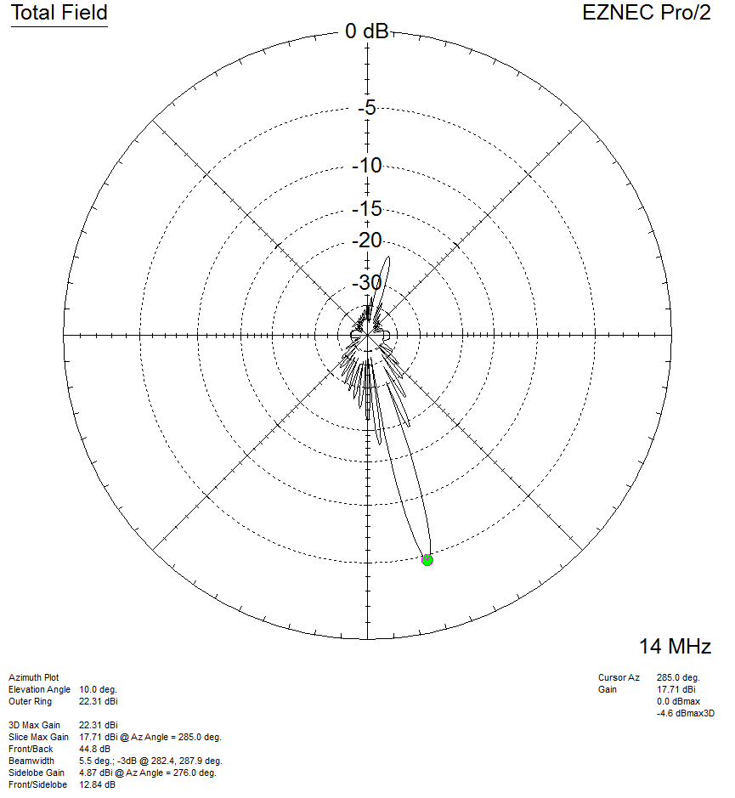

15° Steered, Azimuth slice, 15° elevation, 14MHz:
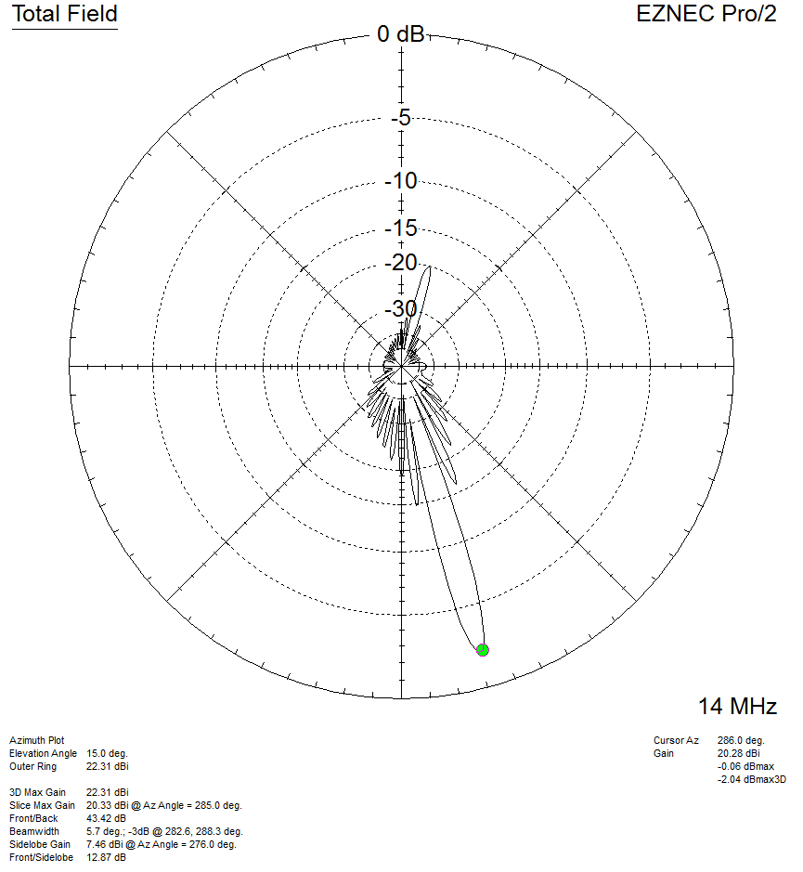

15° Steered, Azimuth slice, 20° elevation, 14MHz:
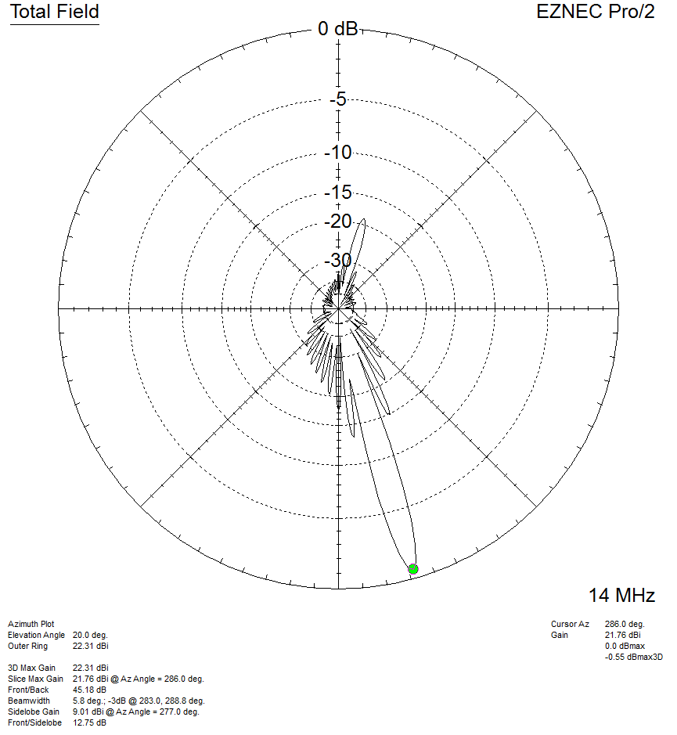

15° Steered, Azimuth slice, 25° elevation, 14MHz:
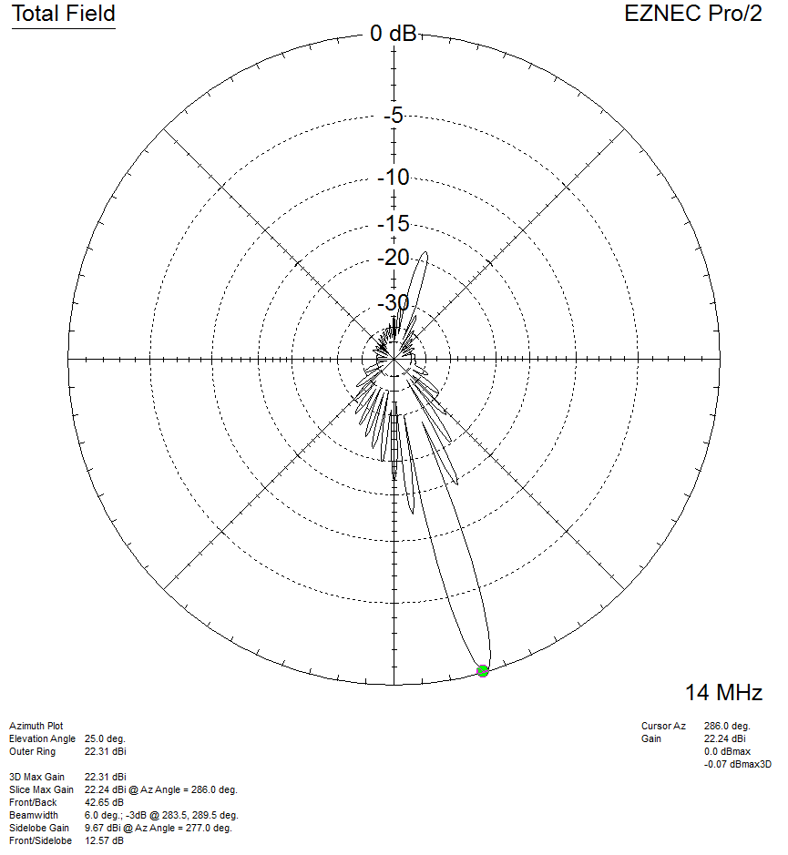

15° Steered, Azimuth slice, 30° elevation, 14MHz:
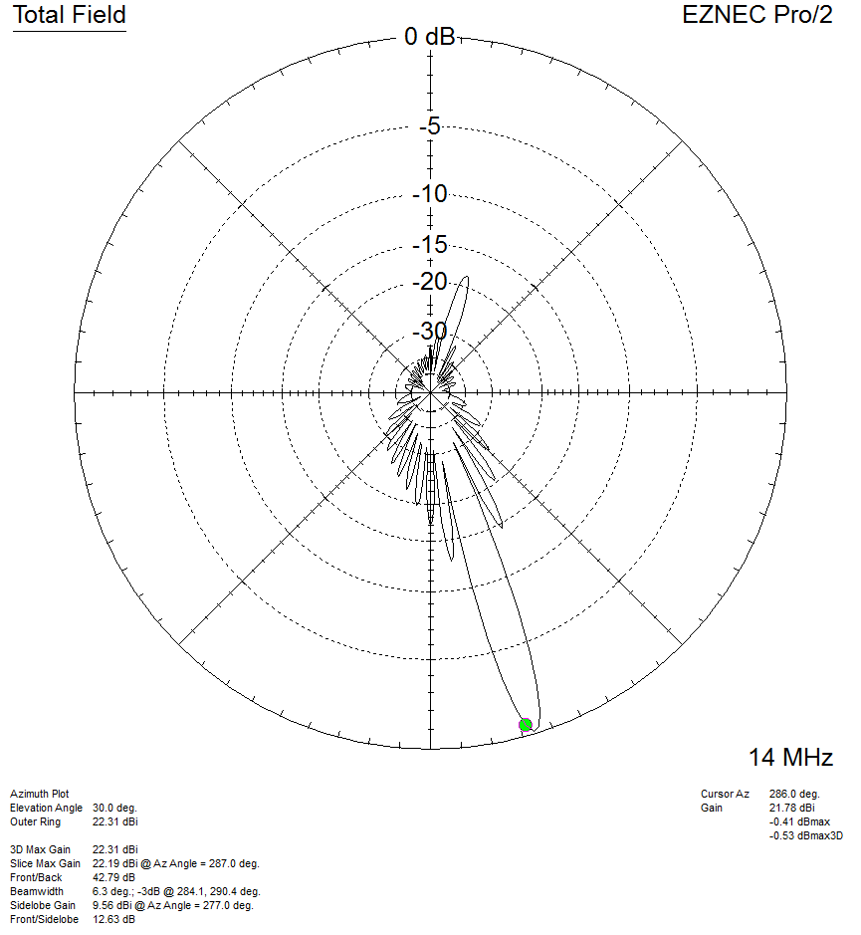

15° Steered, Azimuth slice, 35° elevation, 14MHz:
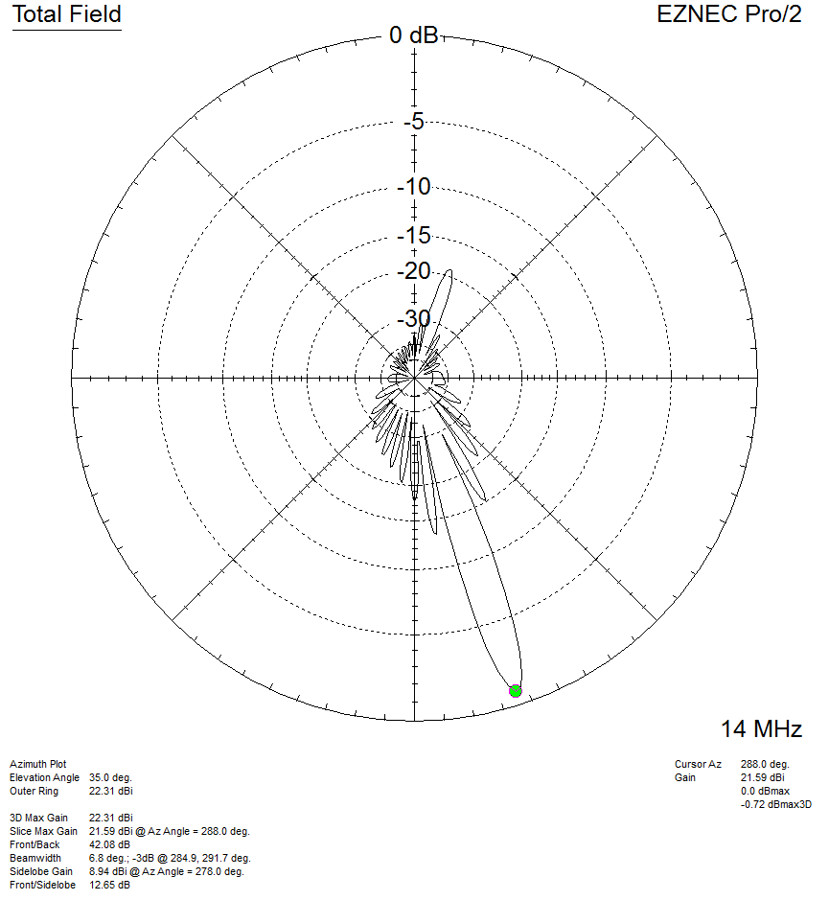

15° Steered, Azimuth slice, 40° elevation, 14MHz:
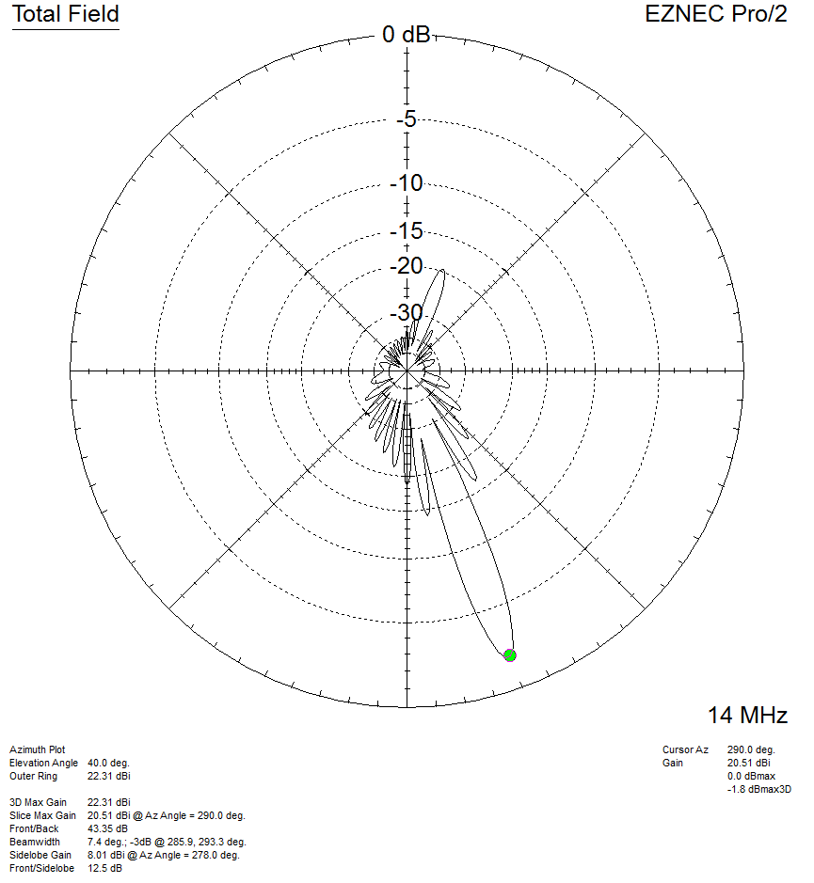

15° Steered, Azimuth slice, 45° elevation, 14MHz:
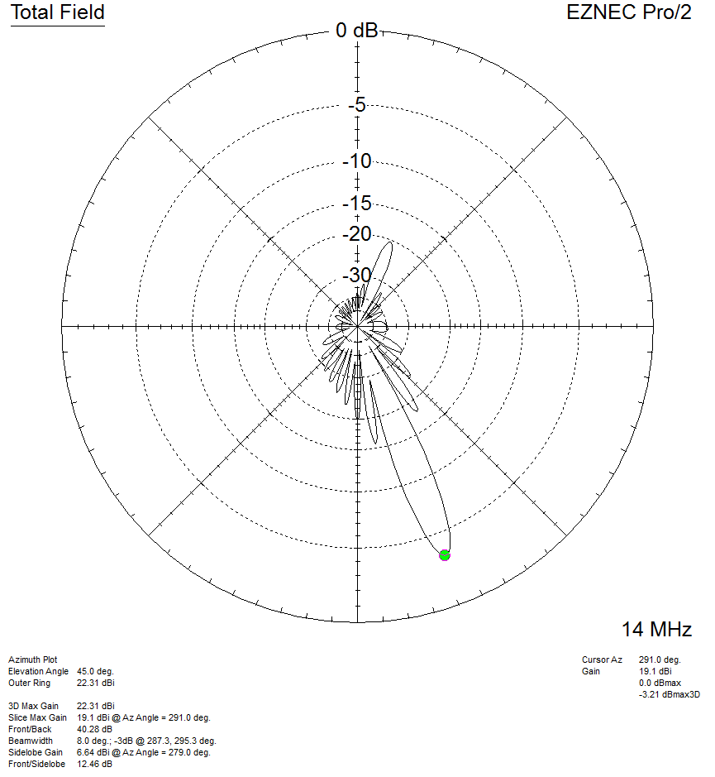

3D pattern at 11 MHz (steered 30° off boresight):
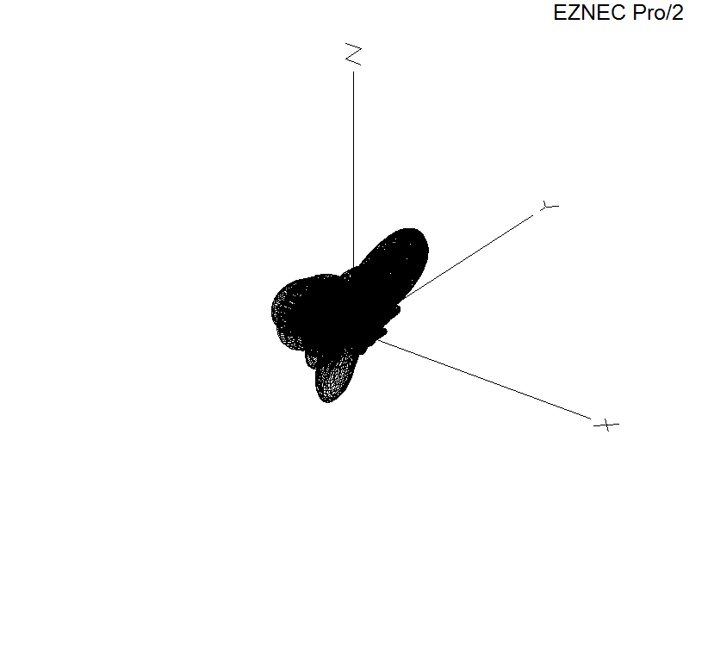

30° Steered, Azimuth slice, 10° elevation, 11MHz:
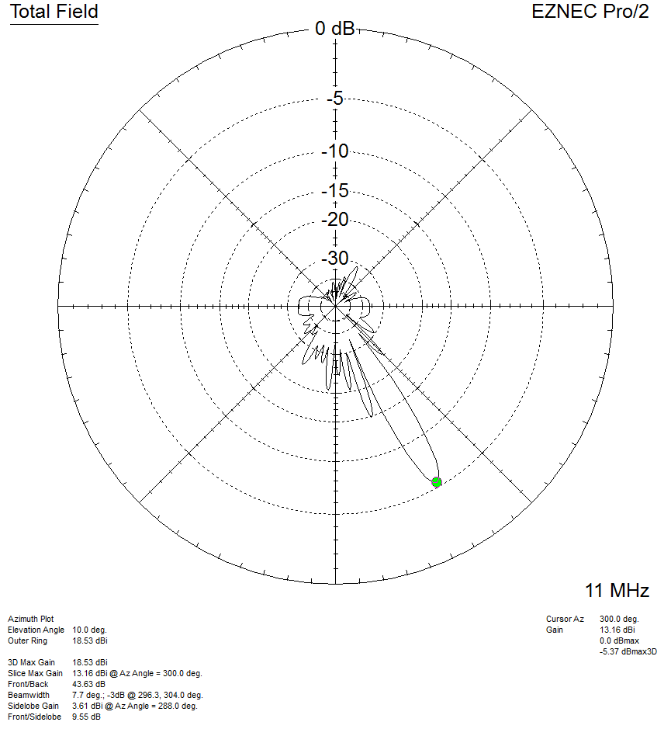

30° Steered, Azimuth slice, 15° elevation, 11MHz:
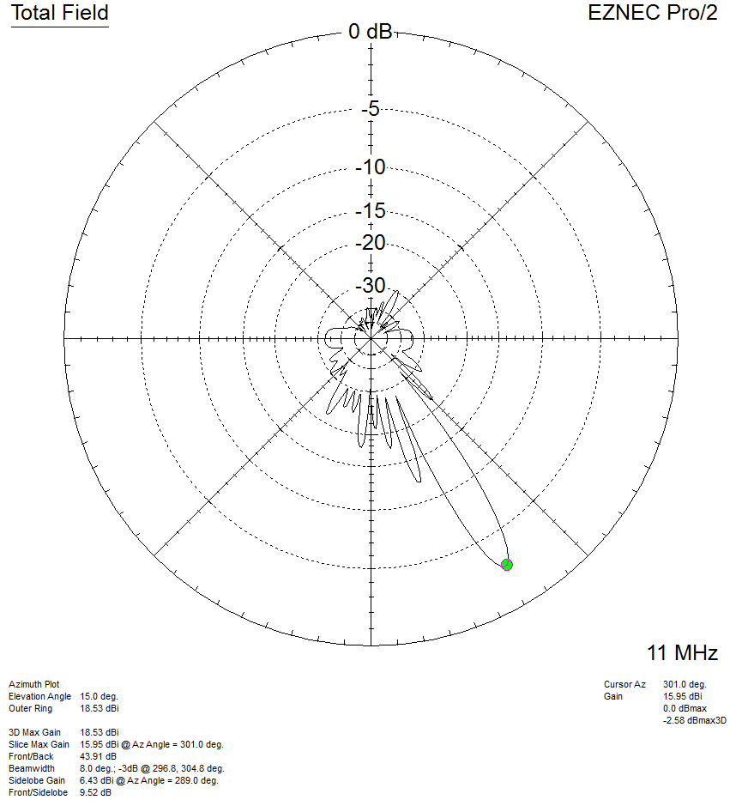

30° Steered, Azimuth slice, 20° elevation, 11MHz:
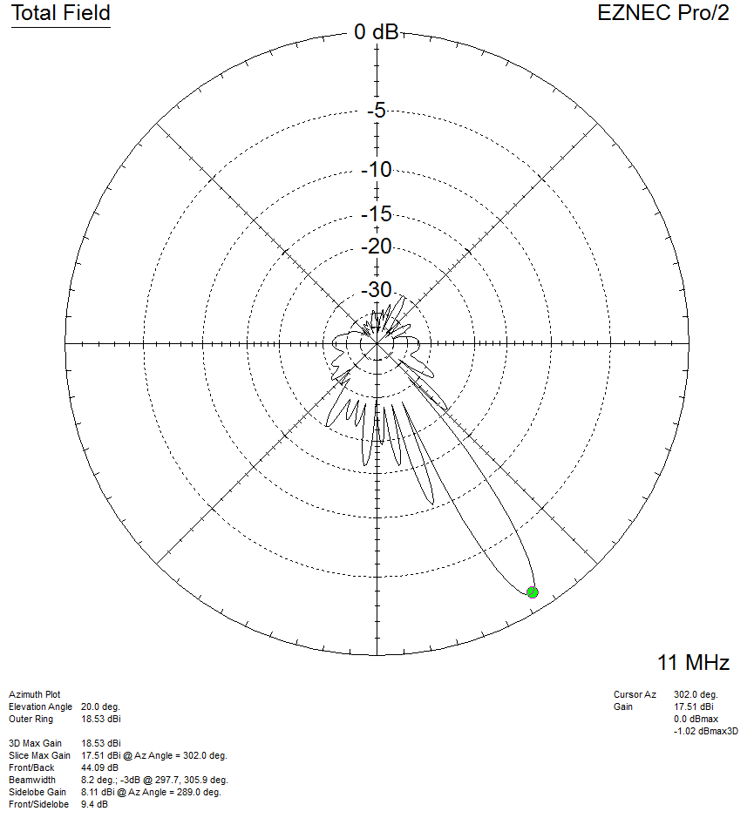

30° Steered, Azimuth slice, 25° elevation, 11MHz:
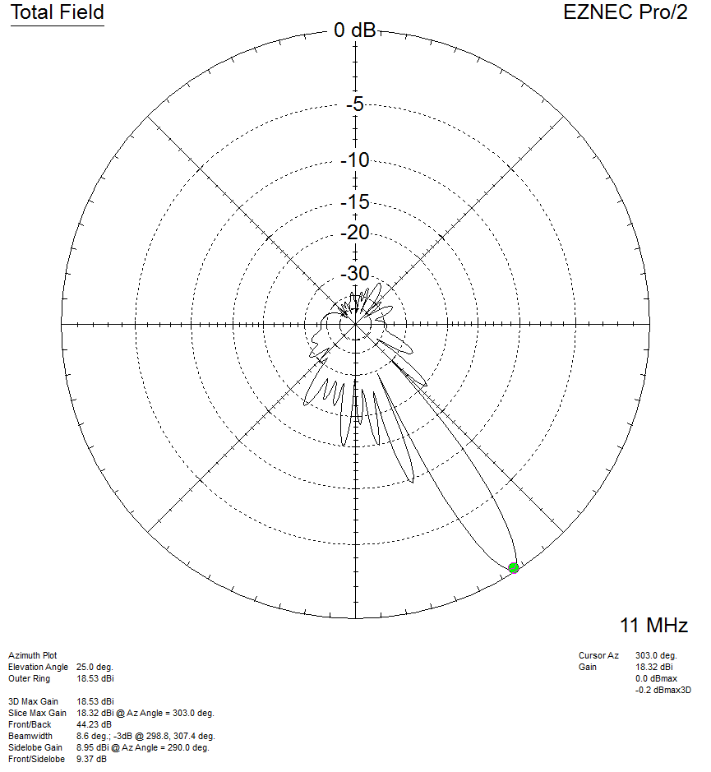

30° Steered, Azimuth slice, 30° elevation, 11MHz:
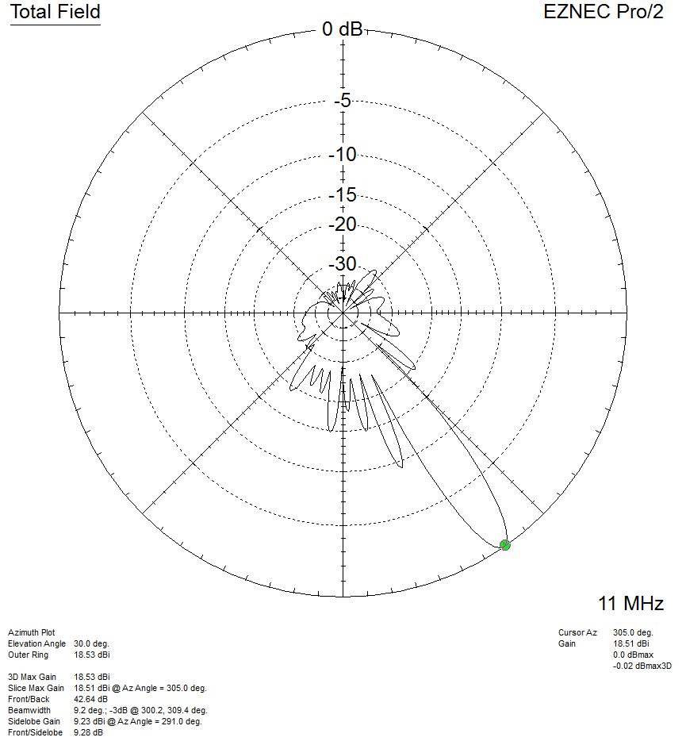

30° Steered, Azimuth slice, 35° elevation, 11MHz:
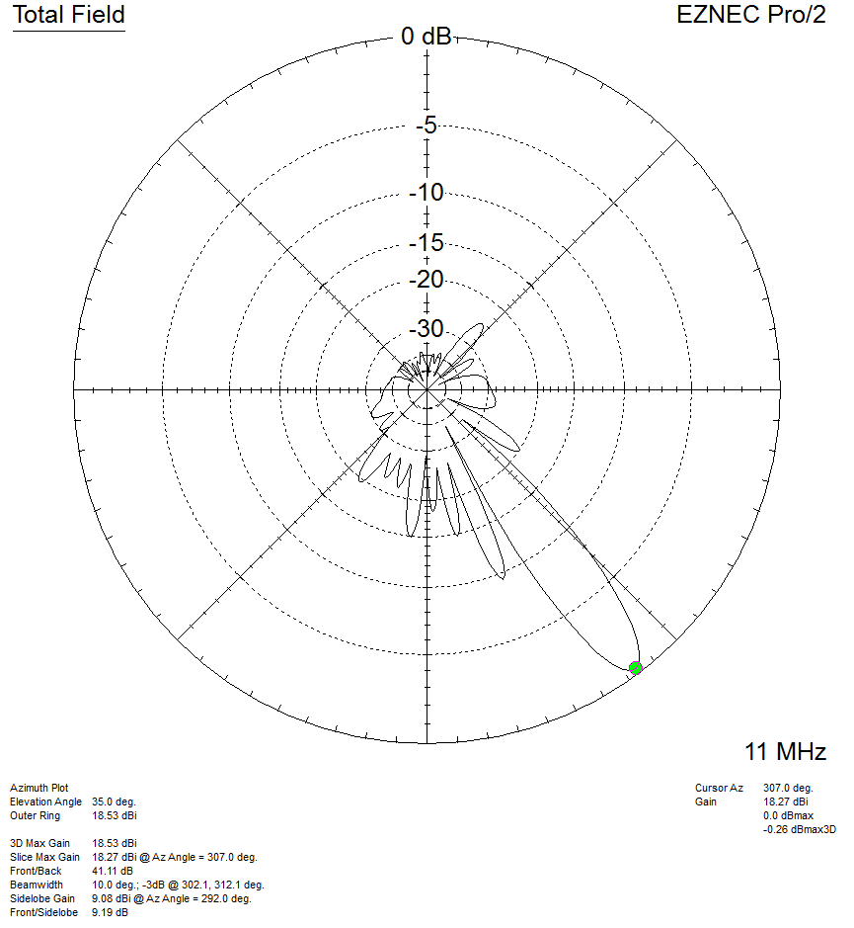

30° Steered, Azimuth slice, 40° elevation, 11MHz:
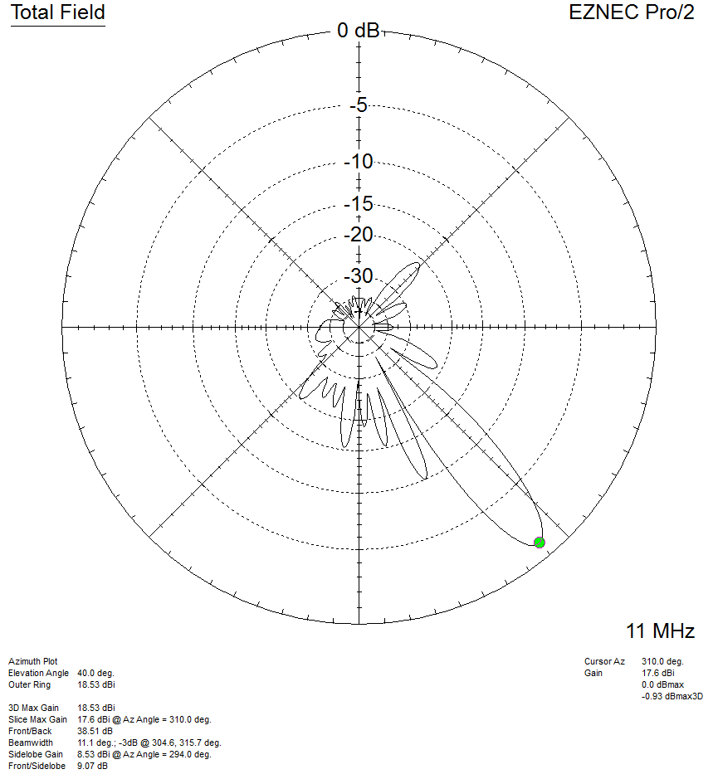

30° Steered, Azimuth slice, 45° elevation, 11MHz:
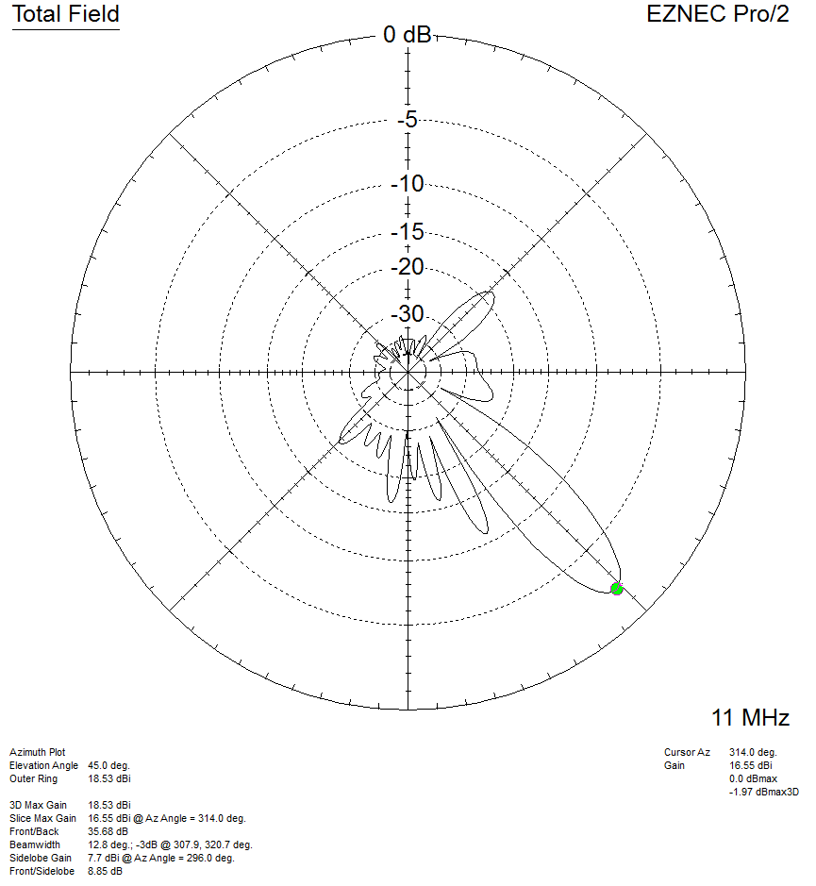

3D pattern at 14 MHz (steered 30° off boresight):
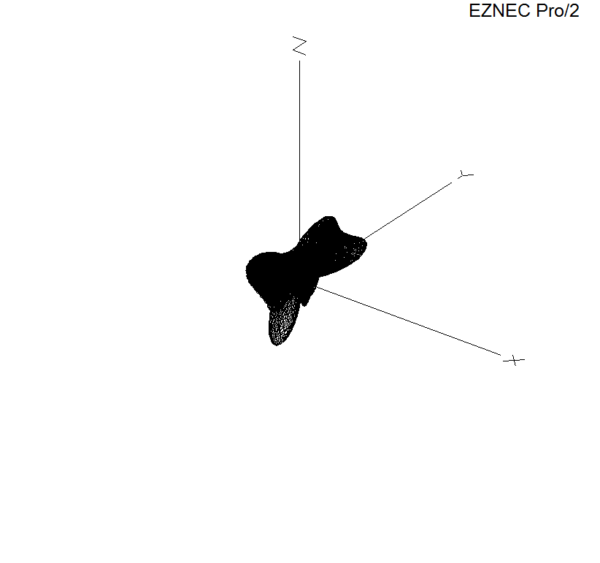
30° Steered, Azimuth slice, 10° elevation, 14MHz:
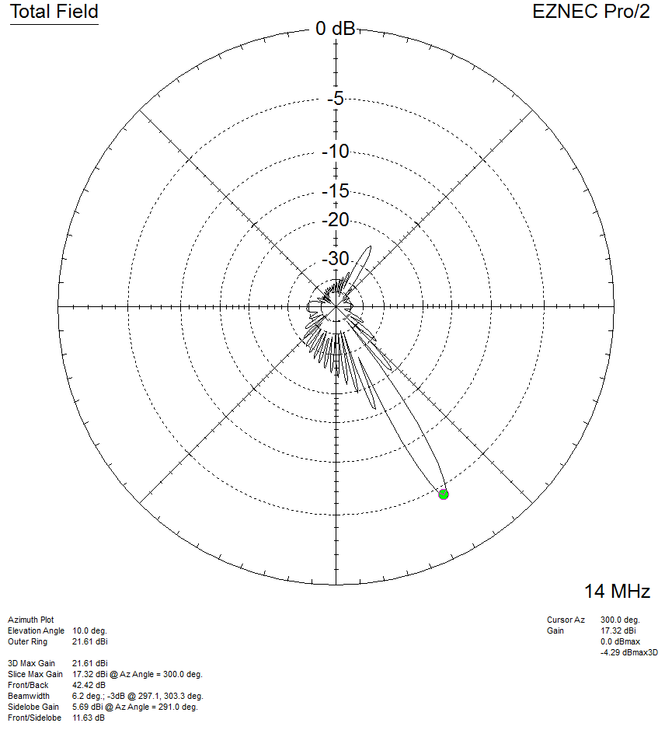

30° Steered, Azimuth slice, 15° elevation, 14MHz:
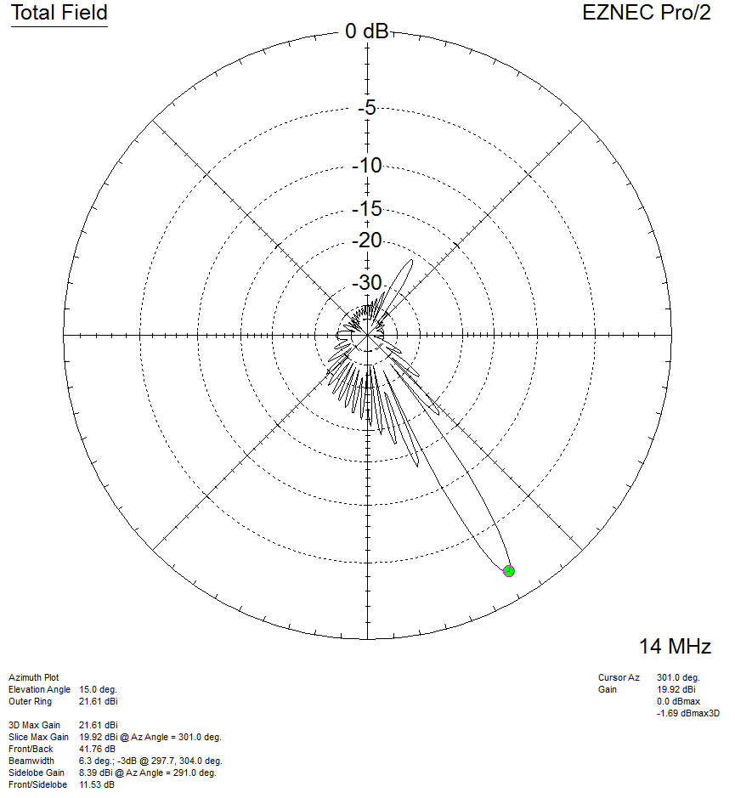

30° Steered, Azimuth slice, 20° elevation, 14MHz:
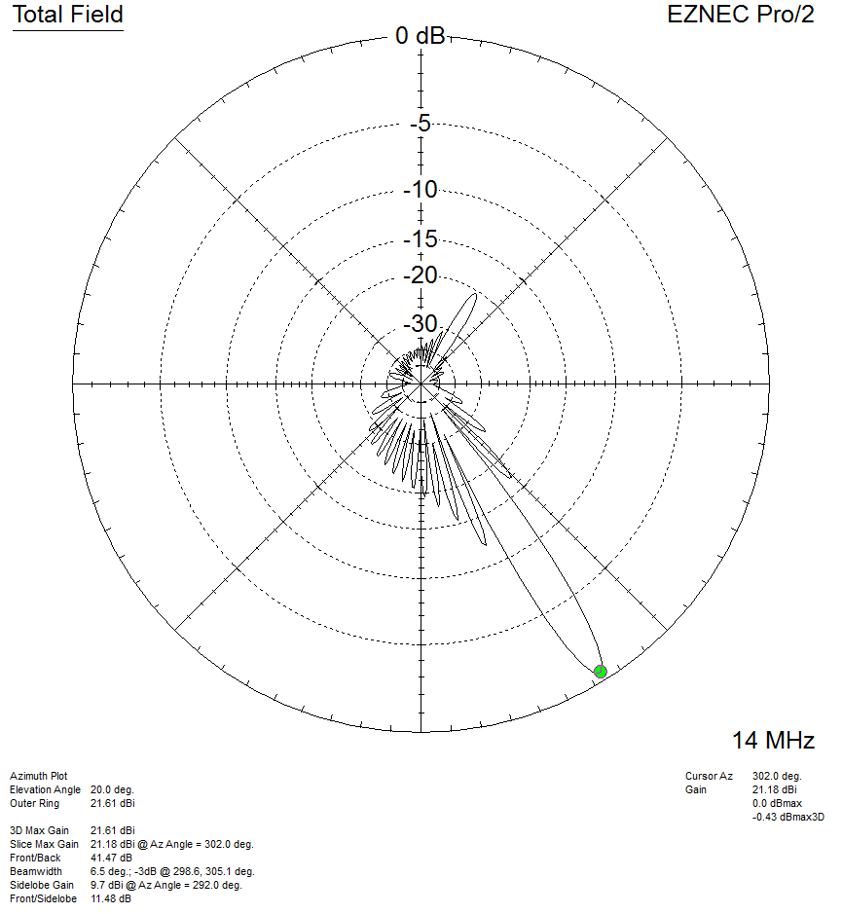

30° Steered, Azimuth slice, 25° elevation, 14MHz:
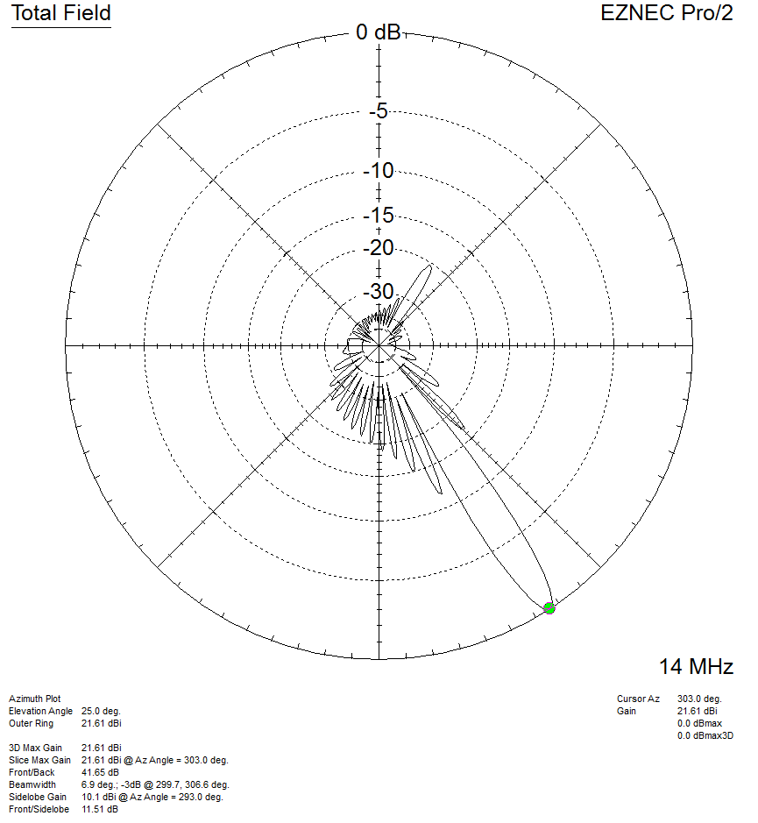

30° Steered, Azimuth slice, 30° elevation, 14MHz:
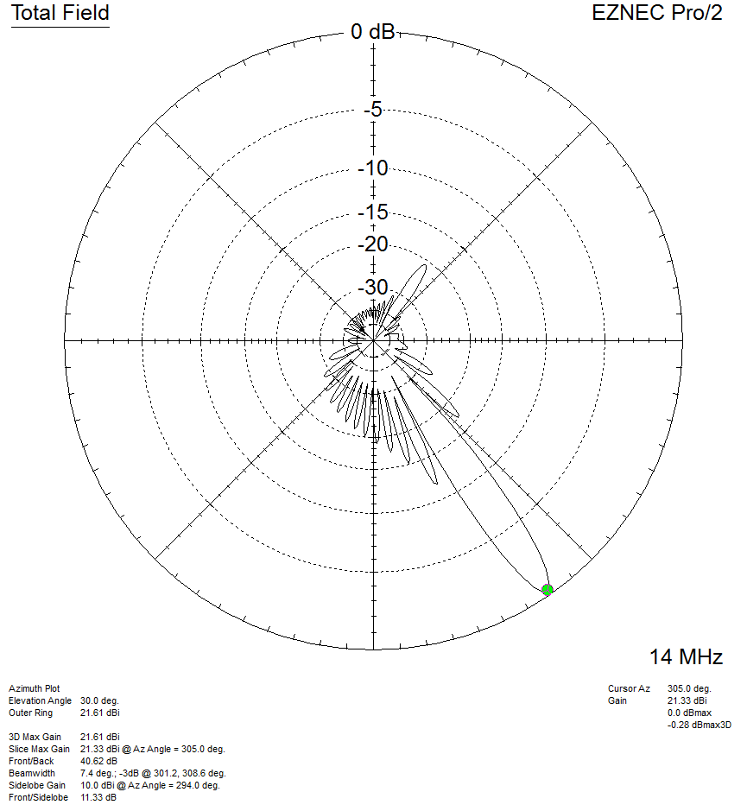

30° Steered, Azimuth slice, 35° elevation, 14MHz:
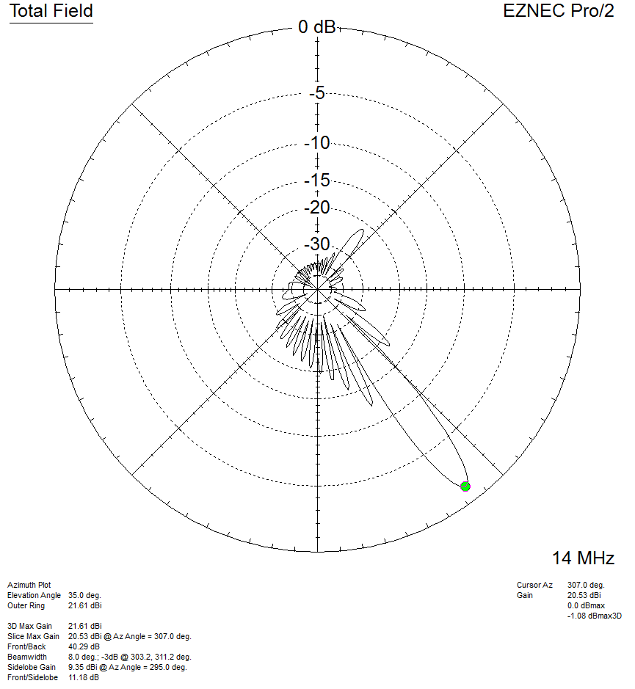

30° Steered, Azimuth slice, 40° elevation, 14MHz:
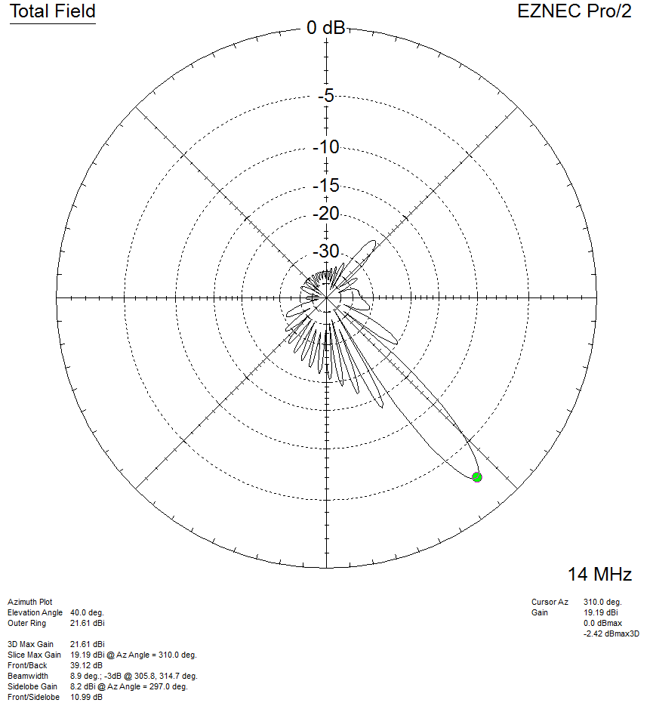

30° Steered, Azimuth slice, 45° elevation, 14MHz:
